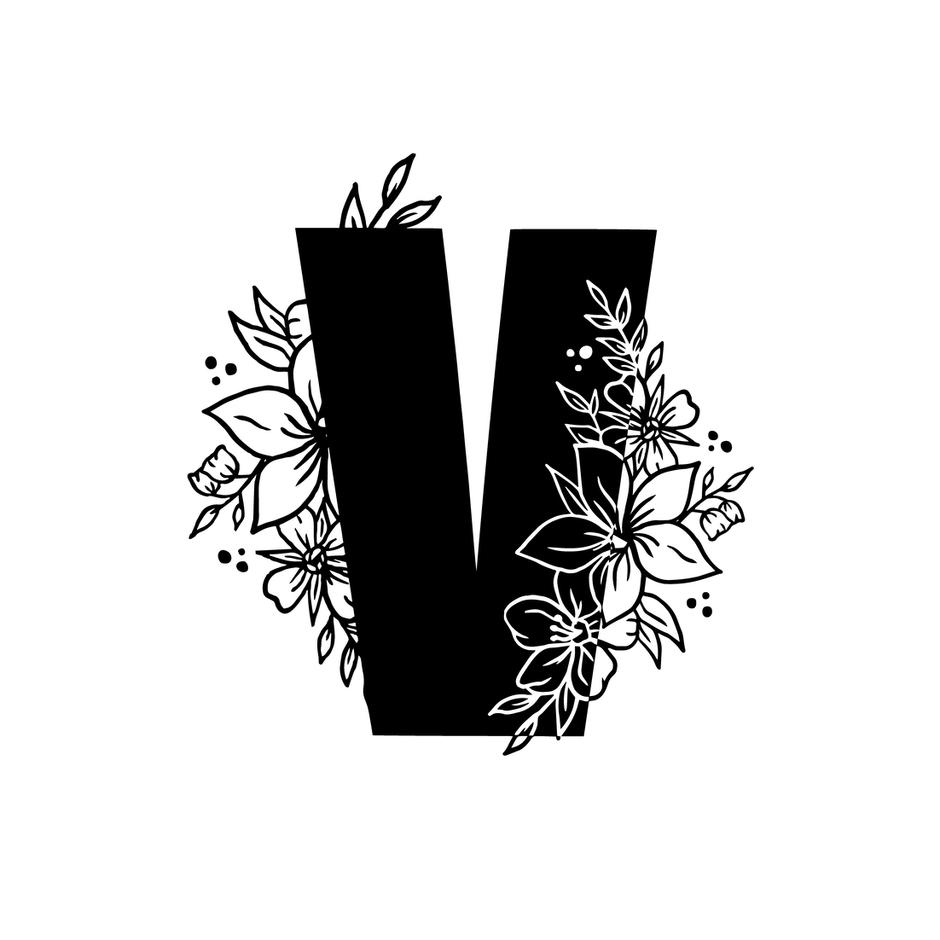

VAINE MAGAZINE

SUBMISSION FORM
· 2O22 ·

S E N D Y O U R
S U B M I S S I O N T O
vainemag@ gmail. com

READ THESE GUIDELINES CAREFULLY BEFORE SUBMITTING

F O L L O W T H E
G U I D E L I N E S
Fill in the form and send it via email to vainemag@gmail.com

THE THEME
We only accept submissions related to the current topic. Please check our Home Page or Instagram to learn more about the theme.

We accept submissions for the following categories:

- Poetry
- Fiction
- Features (articles, interviews, journalism...)
- Art (painting, illustration, collage, photography...)
- Editorials or Photo Series (Photography: Fashion, Conceptual, Fine Art...)

GUIDELINES AND TIPS

- POETRY
If you are submitting poetry please submit no more than 4 poems per submission. Each poem should be formatted in .doc/Word document format (please do NOT send a .pdf). If sending multiple poems, please put them on the same document, with each new poem starting on its own new page. Poems will be published without editing so it is up to the contributor to

ensure their spelling and punctuation is as intended.

N.B spoken word - If your poetry is intended as a spoken word piece/or has been performed as spoken word, please email us at vainemag@gmail.com . You may be invited to do a video performance of your work if selected. Do NOT send us a video in the first instance, always
send your poems in writing first.

·FICTION
If you are submitting short fiction please submit no more than two works per submission.
Each story should be formatted in .doc/Word document format (please do NOT send a .pdf).
If sending multiple works, please put them on the same document, with each new story starting on its own new page. Our word limit for short fiction is 2,000 words per story.

- FEATURES
If you are submitting a piece of non-fiction (e.g. article, interview, review etc) please submit no more than two works per submission. Each piece should be formatted in .doc/Word
document format (please do NOT send a .pdf). If sending multiple works, please put them on the same document, with each new piece starting on its own new page. Our word limit for
features is 2,000 words per piece. Please also write a short pitch giving us the gist of your piece by email to vainemag@gmail.com before sending.

- ART
If you are submitting works of visual art (e.g. collage, paintings, drawings, illustrations,
photography etc) please submit no more than 5 works per submission. Please send a folder via WeTransfer or drive to vainemag@gmail.com including your work accordingly to these
requirements:

Illustration/Collage/Digital Painting
JPG, PNG or/and PDF (send your work in different formats if possible)
300 dpi (To check the size of your image open Photoshop and click the 'Image' menu, then choose 'Image size'. Choose “pixels/inch” from the Resolution drop-down menu if it is not already displayed by default. The number in the Resolution box is the DPI of the image.

CMYK Profile
No watermark/Signature if possible

Copyright owner only

Photography (Including photographs of paintings)
JPG or/and TIFF (send your work in different formats if possible)
300 dpi (To check the size of your image open Photoshop and click the 'Image' menu, then choose 'Image size'. Choose “pixels/inch” from the Resolution drop-down menu if it is not already displayed by default. The number in the Resolution box is the DPI of the photo.)

sRBG profile
No watermark/Signature if possible

Copyright owner only

*Editors will select the final images to publish. Please name each artwork with the title of
the piece (IntoTheDeep_SallySmith, Horizon_SallySmith.jpg...) or using the following formula: e.g: SallySmith1.jpg, SallySmith2.jpg etc.

- EDITORIALS & PHOTO SERIES
f you are submitting an editorial (e.g. fashion, conceptual, fine art photography...) or a photo series (narrative photography, documentary photography...) please submit no more than 10
images per submission. Please send a folder via WeTransfer or drive to vainemag@gmail.com including your images accordingly to these specifications:

JPG or/and TIFF format sRGB profile
300 dpi (To check the size of your image open Photoshop and click the 'Image' menu,
then choose 'Image size'. Choose “pixels/inch” from the Resolution drop-down menu if it is not already displayed by default. The number in the Resolution box is the DPI of the
photo.)

NO watermarks
We only accept submissions from the copyright owner
If you're submitting an Editorial please make sure you provide credits for the team, brands, clothing, etc.

How to credit your team (e.g):
Photography: Sally Smith @sallysmithphoto MUA (Make Up Artist): Ellie Smith @elliemua Stylist: John Smith @johnnystyle_
Creative Director: Sally Smith @sallysmithphoto and Lindsay Gómez @lingoart
Wardrobe: ExampleBrand @example_branduk

*Editors will select the final images to publish. Please name the folder with the title of the series/editorial and then name each artwork. e.g: Roots1_SallySmith.jpg,
Roots2_SallySmith.jpg...

IMPORTANT INFORMATION

- RIGHTS: We can only accept pieces from the copyright holder of the submissions. The artist owns all the rights but you might understand that submitting your work to VAINE Magazine allows us to use it in the following ways:

- to publish it in online/digital format.
- to publish it on social media (Instagram, Facebook, Twitter...) and on the VAINE Magazine website.

- PAYMENT: We are currently paying contributors for their work. Payment comprises a fixed £20 fee to be paid to the author of the work on publication of the magazine.
Submissions which comprise of multiple works will be paid the same as those of single works.

- CREDITS: Add all Instagram handles of authors. If you don't send them upon initial submission, we cannot guarantee you will be tagged.

- THEME: It is desirable that all your submissions fit the theme of each issue. Check the open call for submissions poster at home page or our Instagram feed.

- EXCLUSIVITY: We prioritize exclusive and unpublished pieces. Although we accept some non exclusive work if fits our publication.

- DIVERSITY: Our publication prides itself on showcasing the diversity within our generation.

COMMON REASONS FOR REJECTION:
- Your submission does not comply with our requirements or guidelines.
- You have sent more pieces than permitted.
- Your work is unsuitable or does not fit with the theme or values.
- Images contain watermarks.

+ All submissions will be reviewed – Submission does NOT mean publication
+ By submitting to VAINE Magazine, you agree to the terms and agreements.

CONTRIBUTOR FORM

*FULL NAME / ARTISTIC NAME __________________________

*BIO (PLEASE WRITE A SHORT BIO - UNDER 100 WORDS - USING THE 3RD PERSON)

_______________________________________________________________
________________________________________________________________

________________________________________________________________
________________________________________________________________

________________________________________________________________
______________________

PHOTO - Optional (PROVIDE A BLACK & WHITE PHOTO IF
POSSIBLE) -This will be used on the 'Contributor' page on our website, and in our print issue or social media posts.

*SOCIAL MEDIA / WEBSITE __________________________

*SUBMISSION TYPE (Poetry, Fiction, Features, Art or Editorial)

_______________________________________________________________
__________________________

*SUBMISSION TITLE (Please give a title for each individual work
you're submitting, if your works form part to a series please provide the series title too)

_______________________________________________________________
__________________________

NOTES
_____________________________________________________
_____________________________________________________
_____________________________________________________
_____________________________________________________
_____________________________________________________
_____________________________________________________
_____________________________________________________
_____________________________________________________
_____________________________________________________
_____________________________________________________
_______

